FIT 9137 – Assignment 2
Task a)
See assignment2.imn
I chose the R1 – R4 – R3 – R2 routes. Because the latency uses us as unit, which is very small, so comparing with bandwidth, it is negligible. I picked up 36, 85, and 97 which have 1 Gbps speed as the route.
Task b)
Error 1:
iPv4 address for intranet is 164.240.24.12/24, but the network is 164.240.79.0/24
How I found it:
After I created the static routing, I found that other clients cannot connect to intranet.
The fix:
Change 164.240.24.12/24 to 164.240.79.12/24
Test the fix:
Run 2-node command for every other clients and intranet. Now they can all connect to intranet.
Error 2:
dnsserver has address 164.240.58.12/27, which is the wrong subnet represent.
How I found it:
I was checking switch4 and found that dnsserver is a bit different from the other two.
The fix:
Change 164.240.58.12/27 to 164.240.58.12/24
Test the fix:
Run 2-node command between dnsserver and www, ssh.
Error 3
R4 has address 164.240.85.1/24, which conflicts with R3
How I found it:
Run the 2-node command and found that there’s only one gateway in the connection between R4 and R3.
The fix:
Change 164.240.85.1/24 to 164.240.85.2/24
Test the fix:
Run the 2-node command and found that the packet comes and back between 164.240.85.1 and 164.240.85.2.

Execute lynx www.fit9137
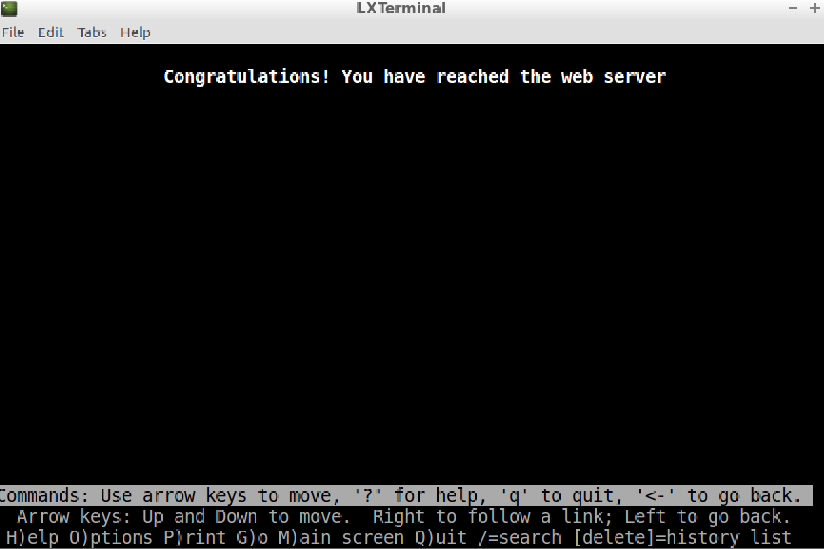
Task c)

